1. Create Payment Table
CREATE DATABASE PaymentManagement;
USE PaymentManagement; 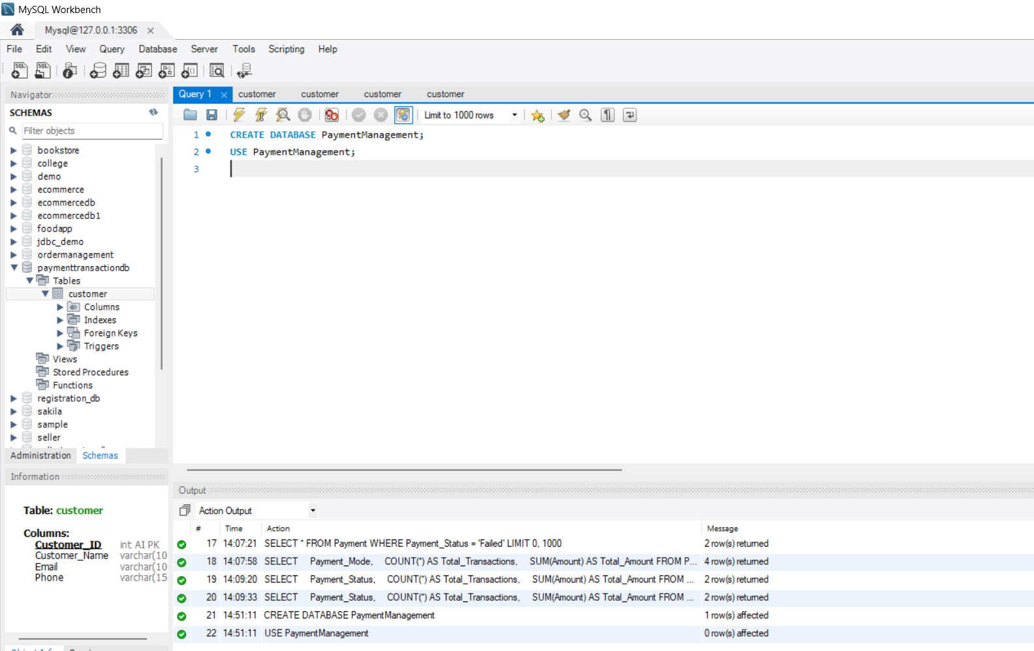

CREATE TABLE Payment (
payment_id INT PRIMARY KEY AUTO_INCREMENT,
customer_name VARCHAR(100) NOT NULL,
amount DECIMAL(10,2) NOT NULL,
payment_mode VARCHAR(30) NOT NULL,
payment_date DATE NOT NULL,
payment_status VARCHAR(20) NOT NULL
); 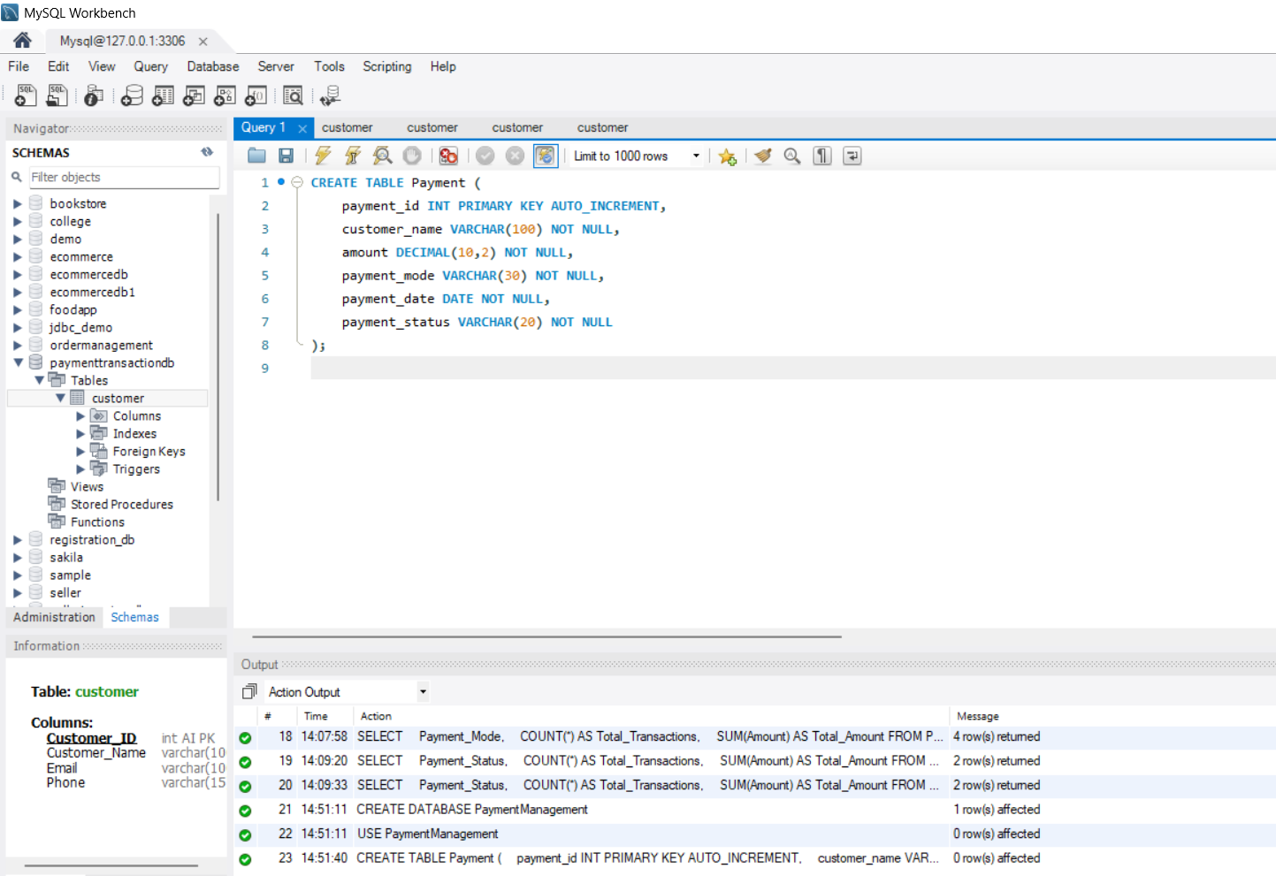
2. Store Payment Details
INSERT INTO Payment
(customer_name, amount, payment_mode, payment_date, payment_status)
VALUES
('Yakesh', 1500.00, 'UPI', '2026-08-17', 'Successful'),
('Arun', 2500.00, 'Credit Card', '2026-08-17', 'Successful'),
('Kumar', 1200.00, 'Debit Card', '2026-08-16', 'Failed'),
('Priya', 3000.00, 'Net Banking', '2026-08-16', 'Successful'),
('Divya', 800.00, 'UPI', '2026-08-15', 'Failed');
View all payments:
SELECT * FROM Payment;
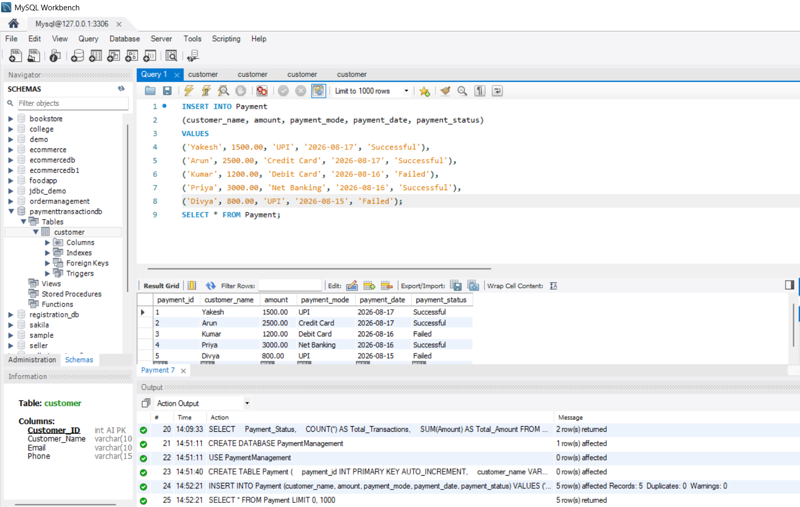
3. Manage Successful and Failed Transactions
Successful transactions:
SELECT *
FROM Payment
WHERE payment_status = 'Successful';
Failed transactions:
SELECT *
FROM Payment
WHERE payment_status = 'Failed';
Update a failed transaction:
UPDATE Payment
SET payment_status = 'Successful'
WHERE payment_id = 3;
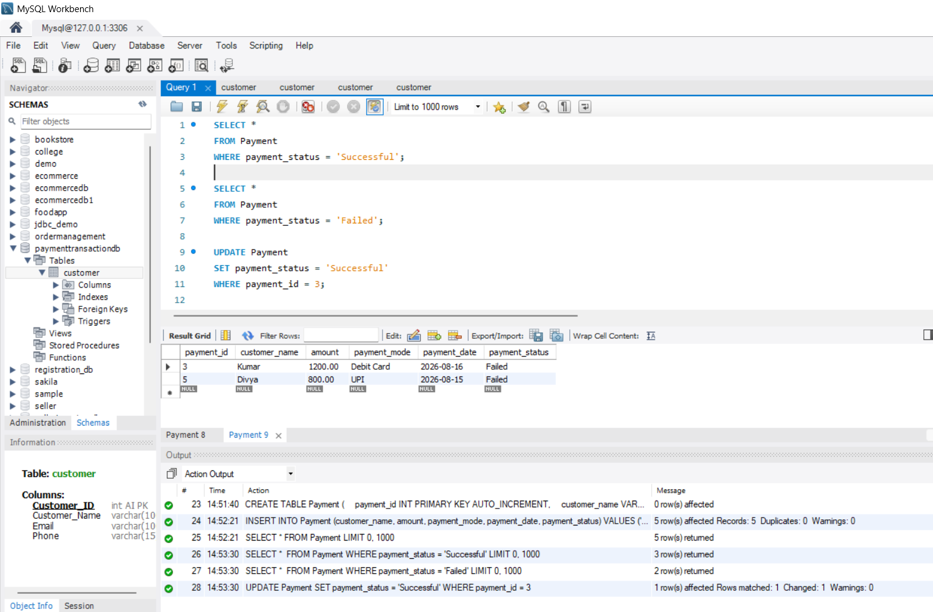
4. Analyze Payment Methods Used by Customers
Count transactions by payment mode:
SELECT payment_mode, COUNT(*) AS total_transactions
FROM Payment
GROUP BY payment_mode;
Total amount collected by payment mode:
SELECT payment_mode, SUM(amount) AS total_amount
FROM Payment
WHERE payment_status = 'Successful'
GROUP BY payment_mode; 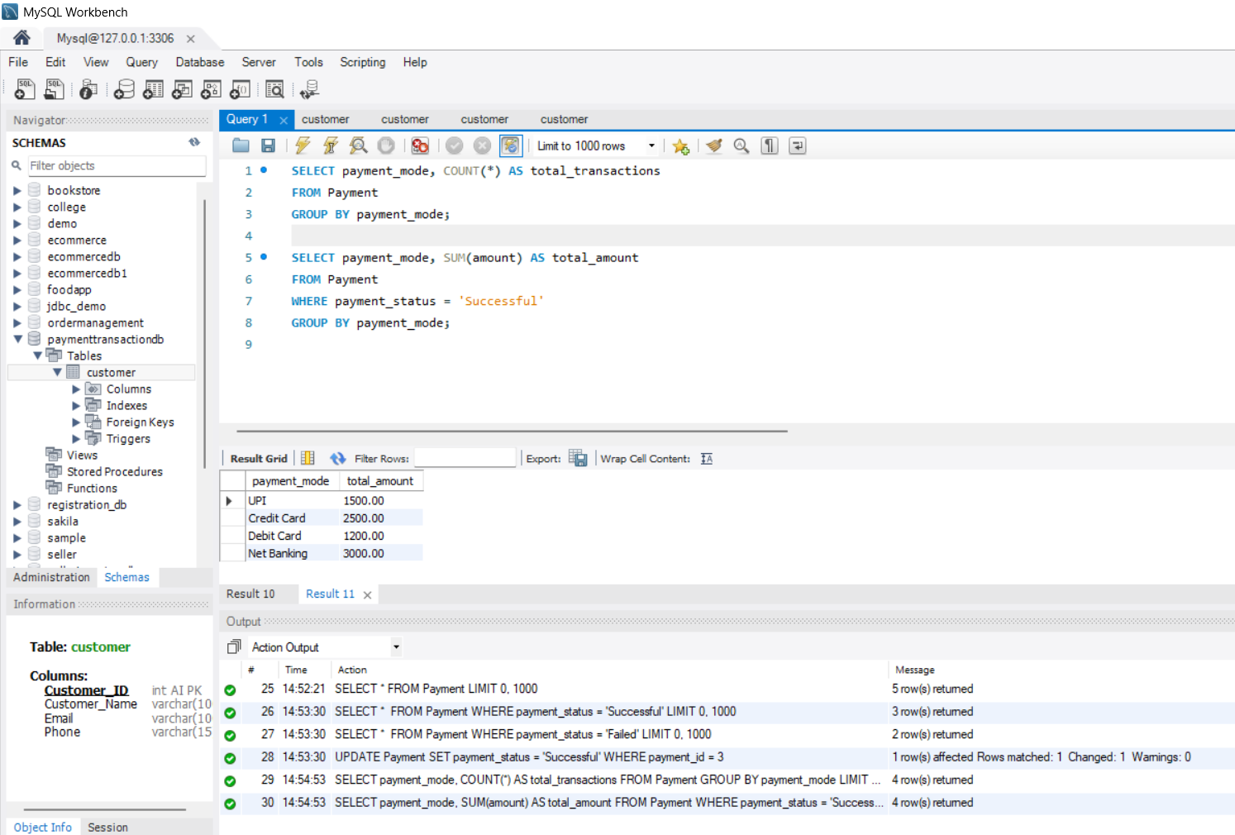
5. Generate Payment Transaction Reports
Total transactions:
SELECT COUNT(*) AS total_transactions
FROM Payment;
Successful transactions:
SELECT COUNT(*) AS successful_transactions
FROM Payment
WHERE payment_status = 'Successful';
Failed transactions:
SELECT COUNT(*) AS failed_transactions
FROM Payment
WHERE payment_status = 'Failed';
Total successful payment amount:
SELECT SUM(amount) AS total_successful_amount
FROM Payment
WHERE payment_status = 'Successful';
Complete payment report:
SELECT
payment_id,
customer_name,
amount,
payment_mode,
payment_date,
payment_status
FROM Payment
ORDER BY payment_date DESC;
